Q1. Write a program to replace a substring inside a string with other string ?

package java1;
public class q1 {
public static void main(String[] args) {
String a="hello how are you";
a = a.replace("how","who");
System.out.println(a);
}
}
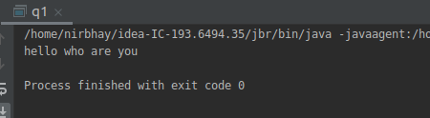

Q2. Write a program to find the number of occurrences of the duplicate words in a string and print them ?

package java1;
public class q2 {
public static void main(String[] args) {
String s="hello abc hello hi hi hi";
String []temp;
int count,i,j;
temp=s.split(" ");
for(i=0;i<temp.length;i++)
{
count=1;
for(j=i+1;j<temp.length;j++)
{
if(temp[i].equals(temp[j]))
{
count++;
temp[j]="0";
}
}
if(count>1 && temp[i]!="0")
{
System.out.println(temp[i] + "=" + count);
}
}
}
}
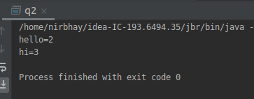

Q3. Write a program to find the number of occurrences of a character in a string without using loop?

package java1;
public class q3 {
static int count=0;
static int len;
public void fun1(String a, int i){
if (a.charAt(i)=='h'){
count++;
}
if(i<len-1){
fun1(a,i+1);
}
}
public static void main(String[] args) {
String a = "hello hi how are you";
len=a.length();
q3 obj=new q3();
obj.fun1(a,0);
System.out.println(count);
}
}
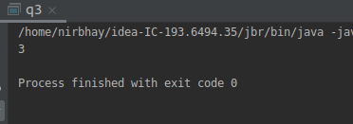

Q4. Calculate the number & Percentage Of Lowercase Letters,Uppercase Letters, Digits And Other Special Characters In A String

package java1;
public class q4 {
public static void main(String[] args) {
String a="hello HOW are YOU @? 100";
int i,lc=0,uc=0,dig=0,sc=0,total=0;
float lcp=0,ucp=0,digp=0,scp=0;
for (i=0;i<a.length();i++)
{
if (a.charAt(i)>=97 && a.charAt(i)<=122){
lc++;
}
else if (a.charAt(i)>=65 && a.charAt(i)<=90){
uc++;
}
else if (a.charAt(i)>=48 && a.charAt(i)<=57) {
dig++;
}
else if (a.charAt(i)>=33 && a.charAt(i)<=47 || a.charAt(i)>=58 && a.charAt(i)<=64 || a.charAt(i)>=91 && a.charAt(i)<=96 || a.charAt(i)>=123 && a.charAt(i)<=126){
sc++;
}
}
total=lc+uc+dig+sc;
lcp=((float)lc/(float)total)*100;
ucp=((float)uc/(float)total)*100;
digp=((float)dig/(float)total)*100;
scp=((float)sc/(float)total)*100;
System.out.println("lower case= " + lc + " -- " + lcp + "%");
System.out.println("upper case= " + uc + " -- " + ucp + "%");
System.out.println("digits= " + dig + " -- " + digp + "%");
System.out.println("special char= " + sc + " -- " + scp + "%");
}
}

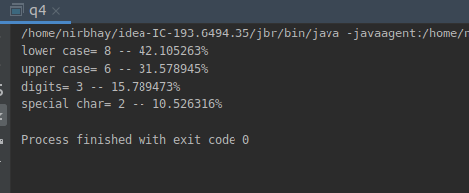

Q5. Find common elements between two arrays.

package java1;
public class q5 {
public static void main(String[] args) {
int[] a = new int[]{ 1,2,3,4,5,};
int[] b = new int[]{ 2,6,3,4,9};
int[] c = new int[10];
int i,j;
for (i=0;i<a.length;i++)
{
for (j=0;j<b.length;j++)
{
if (a[i]==b[j])
{
System.out.println(a[i]);
}
}
}
}
}
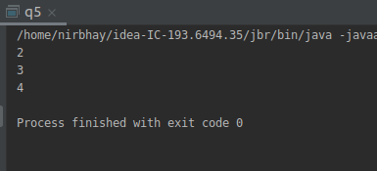

Q6. There is an array with every element repeated twice except one. Find that element

package java1;
public class q6 {
public static void main(String[] args) {
int[] a = new int[]{ 1,3,2,1,2,4,5,4,5};
int i,j,count;
for (i=0;i<a.length;i++)
{
count=1;
for (j=i+1;j<a.length;j++)
{
if (a[i]==a[j])
{
count=2;
a[j]=0;
}
}
if (count==1 && a[i]!=0)
{
System.out.println(a[i]);
}
}
}
}

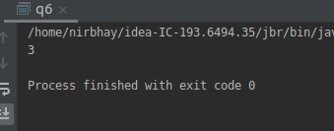

Q7. Write a program to print your Firstname,LastName & age using static block,static method & static variable respectively

package java1;
public class q7 {
static {
String l_name="khurana";
System.out.println("last name="+l_name);
}
static int age=20;
static String f_name="sam";
static void fun1(){
f_name="nirbhay";
}
public static void main(String[] args) {
System.out.println("age="+age);
q7.fun1();
System.out.println("first name="+f_name);
}
}
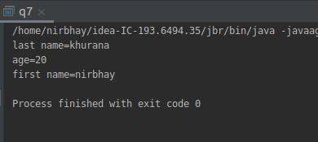

Q8. Write a program to reverse a string and remove character from index 4 to index 9 from the reversed string using String Buffer

package java1;
public class q8 {
public static void main(String[] args) {
StringBuffer a=new StringBuffer("ab987654321");
a.reverse();
System.out.println(a);
a.delete(3,9);
System.out.println(a);
}
}
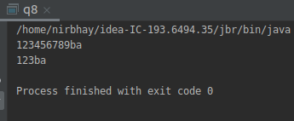

Q9.Write a program to display values of enums using a constructor & getPrice() method (Example display house & their prices)

package java1;
enum House {
H1(20), H2(30), H3(30), H4(30);
int price;
House(int price) {
this.price = price;
}
public int getPrice() {
return price;
}
}
public class q9 {
public static void main(String[] args) {
System.out.println(House.H1.getPrice());
System.out.println(House.H2.getPrice());
System.out.println(House.H3.getPrice());
System.out.println(House.H4.getPrice());
}
}
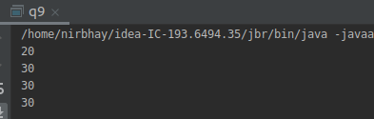

Q10.Write a single program for following operation using overloading
A) Adding 2 integer number
B) Adding 2 double
C) multiplying 2 float
D) multiplying 2 int
E) concate 2 string
F) Concate 3 String

package java1;
public class q10 {
void add(int a,int b)
{
int c;
c= a + b;
System.out.println("INT ADD "+c);
}
void add(double a,double b)
{
double c;
c= a + b;
System.out.println("DOUBLE ADD "+c);
}
void mult(float a,float b)
{
float c;
c= a * b;
System.out.println("FLOAT MULT "+c);
}
void mult(int a,int b)
{
int c;
c= a * b;
System.out.println("INT MULT "+c);
}
void concat(String a,String b)
{
String c;
c= a.concat(b);
System.out.println("2 STRING CONCATE "+c);
}
void concat(String a,String b,String z)
{
String c;
c= a.concat(b).concat(z);
System.out.println("3 STRING CONCATE "+c);
}
public static void main(String args[])
{
q10 o=new q10();
o.add(3,5);
o.add(1.23366,3.87387);
o.mult(3,4);
o.mult(3.12f,3.21f);
o.concat("hello","world");
o.concat("hello","world","!");
}
}

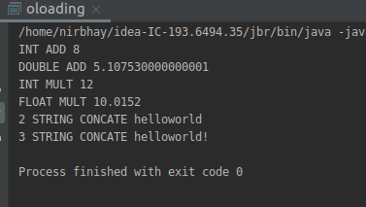

Q11.Create 3 sub class of bank SBI,BOI,ICICI all 4 should have method called getDetails which provide there specific details like rateofinterest etc,print details of every banks

package java1;
class bank {
int rate_of_int;
String branch;
}
class icici extends bank{
icici(int r, String b)
{
this.rate_of_int=r;
this.branch=b;
}
void get_details()
{
System.out.println("rate of interest="+rate_of_int);
System.out.println("branch="+branch);
}
}
class sbi extends bank{
sbi(int r, String b)
{
this.rate_of_int=r;
this.branch=b;
}
void get_details()
{
System.out.println("rate of interest="+rate_of_int);
System.out.println("branch="+branch);
}
}
class boi extends bank{
boi(int r, String b)
{
this.rate_of_int=r;
this.branch=b;
}
void get_details()
{
System.out.println("rate of interest="+rate_of_int);
System.out.println("branch="+branch);
}
}
class q11{
public static void main(String[] args) {
icici o1=new icici(5,"delhi");
o1.get_details();
sbi o2=new sbi(6,"banglore");
o2.get_details();
boi o3=new boi(7,"mumbai");
o3.get_details();
}
}
